SAPvsMES Reporting

**Project Identification**

|  |  |  |
| --- | --- | --- |
| **PR Number:** | **Business Analyst:** | **Date:** |
|  | Rodolfo Cabada | 24/08/2018 |
| **Region:** | **Business Unit:** | **Requestor:** |
| Americas | Tesla | Daniel Vazquez |

|  |  |  |  |  |
| --- | --- | --- | --- | --- |
| **Application Name** | SAPvsMES | | | |
| **Functional Owner** | Daniel Vazquez | | | |
| **IT Owner** | Daniel Ruizesparza | | | |
| **Supported Business Process** | |  | | |
| **Criticality of supported Business Process** | | Low  No direct impact on production | Medium  Limited impact on production, workaround available as alternative if this process stops | High  Significant impact on production, no workaround available, If this process stops, production stops |
| **Is there an alternative system in other locations?** | | Yes  No | | |
| **Description of the alternative:** | | N/A | | |
| **Reasons why alternative is not acceptable:** | | Performance problems  Complexity  Others: | | |
| **Reason of requirement** | | Legal | Customer | SOX |
| Others: | | |

Change History

|  |  |  |  |
| --- | --- | --- | --- |
| **Name of BA** | **PR/IN number** | **Date** | **Description and Page reference (mark with color and use ‘track changes’** |
| Rodolfo Cabada |  | 24/08/2017 | Initial requirements |
|  |  |  |  |
|  |  |  |  |
|  |  |  |  |

Document References

|  |  |
| --- | --- |
| **Document Title** | **Link to document** |
|  |  |
|  |  |

Table of Contents

1 Business Reason and Purpose of the Validation 4

2 Acronym List 5

3 Solution Overview (High Level) 5

3.1 Description of the Process and Summary of Improvements 7

3.2 Flowchart 7

3.1 Interfaces 7

3.2 Error Handling 7

4 Authorization Requirements 8

5 Prerequisites 8

6 Hardware / Network requirement 8

7 Test Plan 8

# Business Reason and Purpose of the Validation

SAPvsMES consists in a report that concentrate information from MES and SAP applications to know the quantity of pieces that are in production floor to check the stock in the inventory system (SAP) and the manufacturing system (MES) and in this way to be able to monitor differences between both applications.

Both applications have identified steps for the production process where the PCB’s undergoes a progression, the report relates these steps of one application with those of the other, in the SAP application only exists steps where the PCB’s undergoes a progression and in MES application exists more steps where not necessarily the PCB’s undergoes a progression, because of this is necessary to do this relationship. With this relationship it can be possible to do a checkpoint for both application and compare the stock of pieces that reports each one.

It’s important have in mind the correct hour to obtain the information of both application to generate the report this because SAP is refresh one time each hour and MES is in real time, is necessary to synchronize the obtaining of the information to have accurate data.

A version of the report exists for Tesla customer without the possibility of select other customers, the requirement is that it can be generated for any customer.

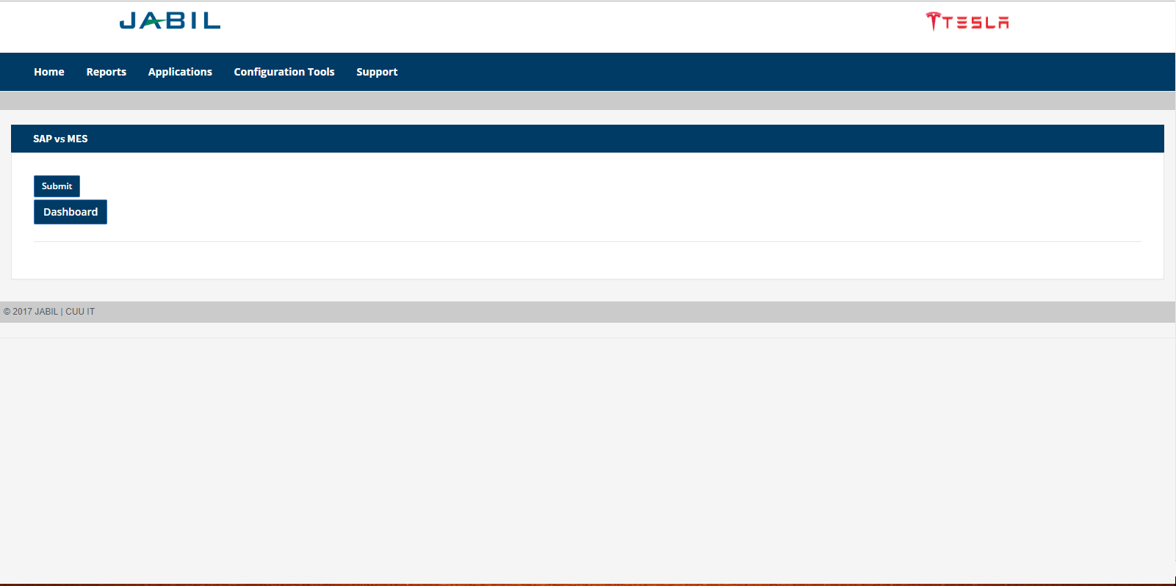

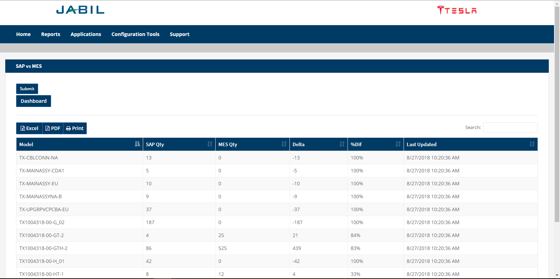

The current version of SAPvsMES don’t have the option to select a customer and only it’s possible to generate the report for Tesla customer. This version has a Dashboard option that shows information in a graphic way but also only it’s possible to generate for Tesla customer, this option only will be available for that client if the user selects other customer this option will be hidden, the migration for this option will be in the second phase of the project.

# Acronym List

|  |  |
| --- | --- |
| **Acronym** | **Description** |
| PCB | Printed Circuit Board |
| MES | Manufacturing Execution System |
| SAP | Systems, Applications, Products |

# Solution Overview (High Level)

The proposed solution is modify the current report and graphic interface to have the option to select the customer, also modify the database job wich update the data of the report this to synchronize correctly both applications and obtain accurate data.

Once the solution is complete the user can select the desired customer to generate the report. The first phase of the solution consists in modify the current implementation of the report to Tesla customer in a staging enviroment and compare the information with the version of production environment. Once the Tesla customer is succesfully migrated the Jhon Deere and Eurotech customers will be implemented, since they are the customers that have the backflush automatic process.

**System Architecture**

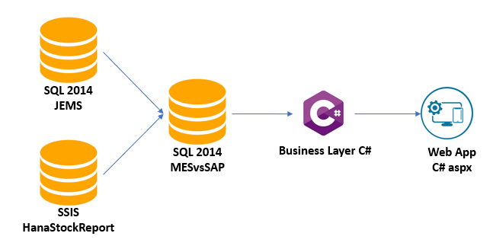

**User Graphic proposal**

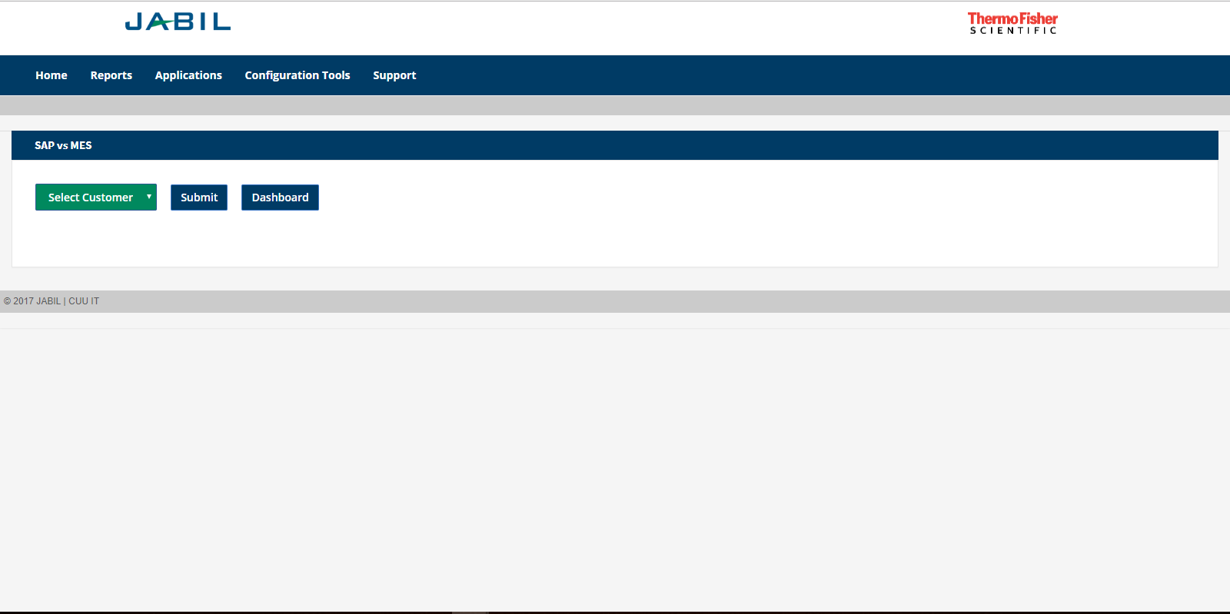

The change for the user graphic interface is only to include an option to select a customer before generating the report.

## Description of the Process and Summary of Improvements

The user selects a customer then the application shows the report with the information and logo of that customer.

**Process Steps:**

1. The user selects a customer.
2. The user clicks on submit option.
3. The application shows the information and logo of the selected customer.

## Flowchart

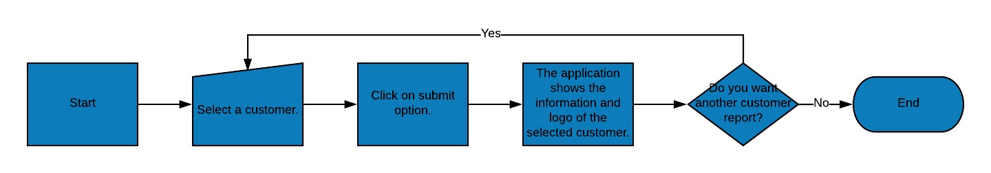

**Project plan**

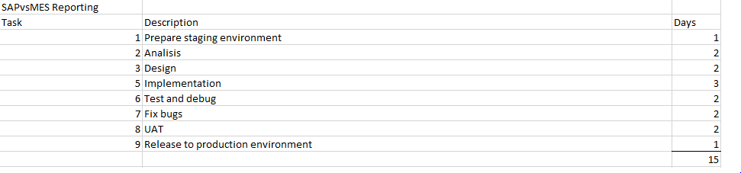

## Interfaces

**N/A**

## Error Handling

The error handling will be manage by:

|  |  |  |  |
| --- | --- | --- | --- |
| **Field name or screen name** | **Condition** | **Message** | **Message type (Error, Warning, Information)** |
| Submit | If a customer was not selected. | Please select a customer. | Information. |

# Authorization Requirements

* The implementation of the production version must be approved by the Jabil’s Change Manager Board though a Change Request ticket.

# Prerequisites

1. Access and permissions to JEMS and MESvsSAP databases.
2. Access to SSIS HanaStockReport package.
3. Permissions on the mxchim0sqlv03a server to modify the properties of the Job HanaStockReport.

# Hardware / Network requirement

The following hardware requirements are included into the project plan:

* Application server to host the web application SAPvsMES.
* SQL Server v2014 to keep hosting the Database, 10 Gbs of additional HD space will be required.

# Test Plan

|  |  |  |  |  |
| --- | --- | --- | --- | --- |
| **Step** | **System** | **Transaction** | **Steps with optional and mandatory input parameters**  **(Please check if test data are valid in the specified system!)** | **Expected Results** |
| 1 | SAPvsMES | Generate the report of Tesla customer after of the change of implementation. | -Open the SAPvsMES application.  -Select the Tesla customer.  -Click on the submit option. | The application must display the report with the logo and the information of Tesla customer and must match with the information displayed in the production environment. |
| 2 | SAPvsMES | Generate the report of Eurotech customer. | -Open the SAPvsMES application.  -Select the Eurotech customer.  -Click on the submit option. | The report must be shown successfully, and the information displayed must be validated by the customer. |
| 3 | SAPvsMES | Generate the report of JDES customer. | -Open the SAPvsMES application.  -Select the JDES customer.  -Click on the submit option. | The report must be shown successfully, and the information displayed must be validated by the customer. |